FISH FOSSIL RECORD FAMILY TREE ACTIVITY
Name______________________________________
BACKGROUND:
Fish in the fossil record are very common because they have hard body parts and they may die in areas that get covered in sediments quickly at times. In this lab, you’ll look at some fish that went extinct in relatively recent time. They will be found in rock layers that are named for glaciation time periods. “Wyomington” is so named for the time period when the North American glaciers reached into Wyoming. “Ohioian” rock layers formed when the glaciers were in Ohio, and so on.
From the rock layers and fossil distributions, we can sometimes get a good idea of the family tree of a fossil. You will not only place fossils in their layers, but also construct a family tree of this “fish”
Objectives:
- analyze characteristics of fossils
- compare placement of fossils and determine relationships
- develop a “family tree” based on the features and ages of fossils
Background
Fossils are traces of organisms that lived in the past. When fossils are found, they are analyzed to determine the age of the fossil. The absolute age of the fossil can be determined though radiometric dating and determining the layer of rock in which the fossil was found. Older layers are found deeper within the earth than newer layers.
The age and morphologies (appearances) of fossils can be used to place fossils in sequences that often show patterns of changes that have occurred over time. This relationship can be depicted in a sort of “family tree”, also known as a phylogenetic tree.
There are two major hypotheses on how species can change into new species: gradualism and punctuated equilibrium. Gradualism suggests that organisms go through a process of slow and constant changes that accumulate. For instance, an organism that shows a fossil record of gradually increased size in small steps, or an organism that shows a gradual loss of a structure. Punctuated equilibrium suggests that species change very rapidly and then stay the same for a large period of time. This rapid change is attributed to a mutation in a few essential genes. The sudden appearance of new structures could be explained by punctuated equilibrium
PRE-LAB QUESTIONS:
- How could you tell if two species of fish are closely related?

- What are some reasons why an organism’s features might look different from its ancestors?

PROCEDURES:
- Cut out all of the Fossil Fish on the page of fish fossils. Be sure to include their rock layer name below them.
- In your diagram of rock Layers (back of this page) place the fish in their correct location in the rock layers. Be sure to place the “upper” fish in the upper portion of their rock layers, and “lower” in their rock layers. If the fossil doesn’t have “upper” or “lower”, it can be placed in the middle.
- Start at the bottom. Arrange the fossils in a “family tree” format that shows the fossils that are more closely related to each other.
- Connect closely-related fossils to one another so that you have a family tree of fossils.
Time Period/Rock Layer | Began (years ago) | Fossils
Idahoan (the present) | 30,000
Californian | 80,000
Montanian | 170,000
Coloradian | 320,000
Oregonian | 395,000
Texian | 445,000
Nevadian | 545,000
Ohioian | 745, 000
Wyomington (oldest) | 995,000
Fossils
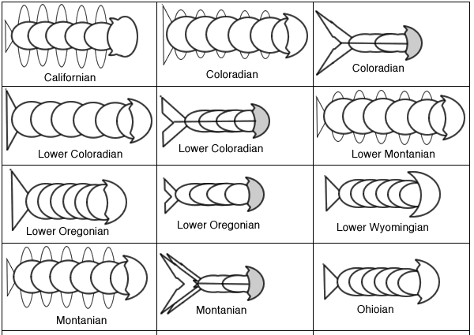
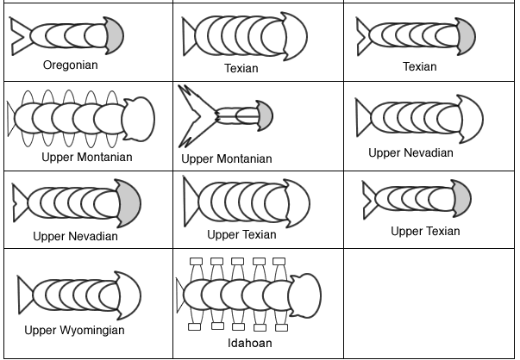

Analysis Questions
- During which time period did the family tree split into two branches?
____________________________________________

- On your diagram, circle an area that demonstrates Punctuated equilibrium, and label it.

- On your diagram, Box in an area that demonstrates gradualism, and label it.

- Examine the fossil that was unearthed in a museum. Apparently the labels and other information were lost. Using your fossil record, determine the time period this fossil is likely from. Explain your reasoning.
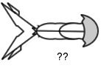

- Of the two major species that arose from the parent species, which had a more successful family? Draw or describe the most successful one, and explain why you are stating that it was more successful.

- What happened to the less successful family, and why do you think this occurred?

BONUS: Find the time period where more changes occurred. Give one logical reason why the amount of changes was greater during this time period.

