Index Fossils Lab 2016-2017
Name _________________________________
PURPOSE:
- Determine which fossils make good index fossils based on their span of existence, physical appearance, and range of existence.
- Use fossils to determine past environments.
- Correlate rock layers of equivalent age using index fossils.

PRE-LAB QUESTIONS:
1. What types of organisms are more likely to become fossilized?

______ Organisms that have
A. Soft bodies B. Hard body parts C. No Bodies

______ Organisms that have been
A. Undisturbed B. Partially eaten C. Trampled after death

______ Organisms that live in
A. Terrestrial Environments B. Aquatic Environments

______ Organisms that are
A. Left exposed for weeks B. Partially buried C. Quickly buried

______ Organisms that die in
A. Oxygen-rich areas B. Oxygen-poor areas

2. What are the 3 things that make a good index fossil?

1)_______________________________________________________________

2)_______________________________________________________________

3)_______________________________________________________________

3. Explain the purpose of index fossils.

_____________________________________________________________________

_____________________________________________________________________

INSTRUCTIONS:
At each lab station, you will read some background information on the given fossil. You will need to:
- Sketch it and take any important notes about the organism,
- Plot it on a set of rock layers on the final page, using the letter given
- Determine the type of fossil, and whether it’s an index fossil
- Plot the age range on the diagram called “Fossil Age Ranges”.

MUCROSPIRIFER BRACHIOPOD
1. Draw a picture of the Mucrospirifer fossil to the right. Then take any notes on the organism you think you may need.

________________________________________________
________________________________________________
________________________________________________
________________________________________________

2. Plot the mucrospirifer fossil on the diagram of the rock layers using the letters “Mc”.

3. Which type of fossil is the fossil?
A. Cast B. Mold C. Permineralization D. Carbon Film

4. Does the Mucrospirifer live up to all 3 Index Fossil requirements? (Check yes or no)
_____Yes _____No Easily identified (even with partial fossils)

_____Yes _____No Lived for a short period of geologic history

_____Yes _____No Found in a lot of areas (Widespread locations)

ORTHOCERAS
1. Draw a picture of the Orthoceras fossil to the right. Then take any notes on the organism you think you may need.

________________________________________________
________________________________________________
________________________________________________

2. Plot the Orthoceras fossil on the diagram of the rock layers using the letters “Or”.

3. Which type of fossil is the fossil?
A. Cast B. Mold C. Permineralization D. Carbon Film

4. Does the Orthoceras live up to all 3 Index Fossil requirements? (Check yes or no)
_____Yes _____No Easily identified (even with partial fossils)
_____Yes _____No Lived for a short period of geologic history
_____Yes _____No Found in a lot of areas (Widespread locations)

WORTHENIA (SNAIL)

1. Draw a picture of the Snail fossil to the right. Then take any notes on the organism you think you may need.

________________________________________________
________________________________________________
________________________________________________

2. Plot the snail fossil on the diagram of the rock layers using the letters “Sn”.

3. Which type of fossil is the fossil?
A. Cast B. Mold C. Permineralization D. Carbon Film

4. Does the snail live up to all 3 Index Fossil requirements? (Check yes or no)
_____Yes _____No Easily identified (even with partial fossils)
_____Yes _____No Lived for a short period of geologic history
_____Yes _____No Found in a lot of areas (Widespread location

SCLERACTINIAN CORAL, “Mushroom Coral”

1. Draw a picture of the Coral fossil to the right. Then take any notes on the organism you think you may need.

________________________________________________
________________________________________________
________________________________________________

2. Plot the coral fossil on the diagram of the rock layers using the letters “Co”.

3. Which type of fossil is the fossil?
A. Cast B. Mold C. Permineralization D. Carbon Film

4. Does the coral live up to all 3 Index Fossil requirements? (Check yes or no)
_____Yes _____No Easily identified (even with partial fossils)
_____Yes _____No Lived for a short period of geologic history
_____Yes _____No Found in a lot of areas (Widespread location

BRYOZOANS

1. Draw a picture of the Bryozoan fossil to the right. Then take any notes on the organism you think you may need.

________________________________________________
________________________________________________
________________________________________________

2. Plot the Bryozoan fossil on the diagram of the rock layers using the letters “Bz”.

3. Which type of fossil is the fossil?
A. Cast B. Mold C. Permineralization D. Carbon Film

4. Does the Bryozoan live up to all 3 Index Fossil requirements? (Check yes or no)
_____Yes _____No Easily identified (even with partial fossils)
_____Yes _____No Lived for a short period of geologic history
_____Yes _____No Found in a lot of areas (Widespread location

TRILOBITES

1. Draw a picture of one of the trilobite fossils to the right. Then take any notes on the organism you think you need.

________________________________________________
________________________________________________
________________________________________________

2. Plot the trilobite fossils on the diagram of the rock layers using the letters “T1” for Elrathia, T2 for Phacops, and T3 for Flexicalymene.

3. Which type of fossil is the fossil?
A. Cast B. Mold C. Permineralization D. Carbon Film

4. Does the trilobite live up to all 3 Index Fossil requirements? (Check yes or no)
_____Yes _____No Easily identified (even with partial fossils)
_____Yes _____No Lived for a short period of geologic history
_____Yes _____No Found in a lot of areas (Widespread location)

FERNS

1. Draw a picture of the fern fossil to the right. Then take any notes on the organism you think you may need.

________________________________________________
________________________________________________
________________________________________________

2. Plot the fern fossil on the diagram of the rock layers using the letters “Fn”.

3. Which type of fossil is the fossil?
A. Cast B. Mold C. Permineralization D. Carbon Film

4. Does the fern live up to all 3 Index Fossil requirements? (Check yes or no)
_____Yes _____No Easily identified (even with partial fossils)
_____Yes _____No Lived for a short period of geologic history
_____Yes _____No Found in a lot of areas (Widespread location)

PETRIFIED WOOD

1. Draw a picture of the petrified wood fossil to the right. Then take any notes on the organism you think you need.

________________________________________________
________________________________________________
________________________________________________

2. Plot the wood fossil on the diagram of the rock layers using the letters “Wd”.

3. Which type of fossil is the fossil?
A. Cast B. Mold C. Permineralization D. Carbon Film

4. Does the wood live up to all 3 Index Fossil requirements? (Check yes or no)
_____Yes _____No Easily identified (even with partial fossils)
_____Yes _____No Lived for a short period of geologic history
_____Yes _____No Found in a lot of areas (Widespread location)

DINOSAUR

1. Draw a picture of the dinosaur fossil to the right. Then take any notes on the organism you think you may need.

________________________________________________
________________________________________________
________________________________________________

2. Plot the dinosaur fossil on the diagram of the rock layers using the letters “D”.

3. Which type of fossil is the fossil?
A. Cast B. Mold C. Permineralization D. Carbon Film

4. Does the dinosaur live up to all 3 Index Fossil requirements? (Check yes or no)
_____Yes _____No Easily identified (even with partial fossils)
_____Yes _____No Lived for a short period of geologic history
_____Yes _____No Found in a lot of areas (Widespread location
PENTREMITES CRINOID

1. Draw a picture of the Blastoid fossil to the right. Then take any notes on the organism you think you may need.

________________________________________________
________________________________________________
________________________________________________

2. Plot the crinoid fossil on the diagram of the rock layers using the letters “Cr”.

3. Which type of fossil is the fossil?
A. Cast B. Mold C. Permineralization D. Carbon Film

4. Does the Crinoid live up to all 3 Index Fossil requirements? (Check yes or no)
_____Yes _____No Easily identified (even with partial fossils)
_____Yes _____No Lived for a short period of geologic history
_____Yes _____No Found in a lot of areas (Widespread location)

ATRYPA BRACHIPOD

1. Draw a picture of the Atrypa fossil to the right. Then take any notes on the organism you think you may need.

________________________________________________
________________________________________________
________________________________________________

2. Plot the Atrypa fossil on the diagram of the rock layers using the letters “A”.

3. Which type of fossil is the fossil?
A. Cast B. Mold C. Permineralization D. Carbon Film

4. Does the Atrypa live up to all 3 Index Fossil requirements? (Check yes or no)
_____Yes _____No Easily identified (even with partial fossils)
_____Yes _____No Lived for a short period of geologic history
_____Yes _____No Found in a lot of areas (Widespread location)
Fossil Age Ranges
Plot the fossil age ranges on this diagram. Then, use this diagram and the Rock Layers diagram to determine the age range of each rock layer.

ROCK LAYER AGE RANGES
Determine the age range for each rock layer AND the type of environment that the rock layer may have been in the past (Aquatic or terrestrial).

A1 Age range=________________________ Environment________________
A2 Age range=________________________ Environment________________
A3 Age range=________________________ Environment________________
A4 Age range=________________________ Environment________________
A5 Age range=________________________ Environment________________
A6 Age range=________________________ Environment________________
A7 Age range=________________________ Environment________________

B1 Age range=________________________ Environment________________
B2 Age range=________________________ Environment________________
B3 Age range=________________________ Environment________________
B4 Age range=________________________ Environment________________
B5 Age range=________________________ Environment________________
B6 Age range=________________________ Environment________________
B7 Age range=________________________ Environment________________

C1 Age range=________________________ Environment________________
C2 Age range=________________________ Environment________________
C3 Age range=________________________ Environment________________
C4 Age range=________________________ Environment________________
C5 Age range=________________________ Environment________________

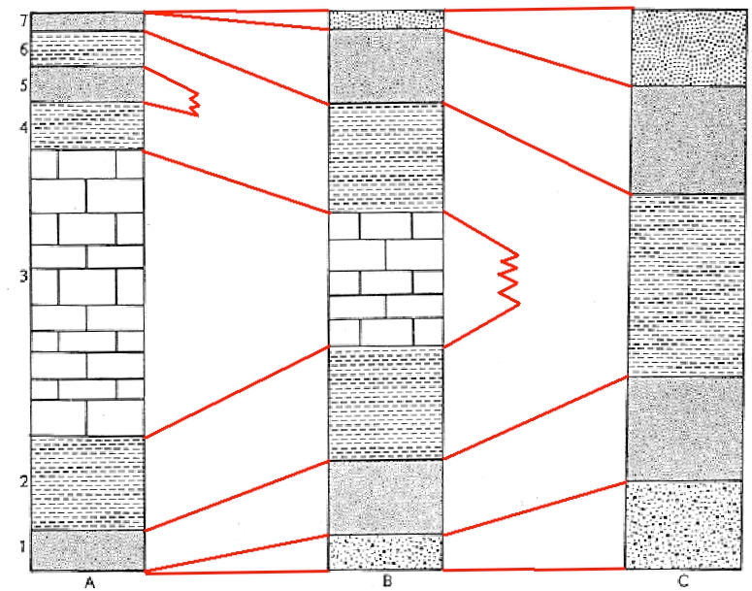
MUCROSPIRIFER (416-359 Million years ago)
1
2
3
4
5
6
7
1
2
3
4
5

Mucrospirifer looks much like modern-day clams and scallops, but it is in no way closely related! This organism is from a group called brachiopods, which dominated the ocean reefs of the world for a very long time before most of them went extinct. They were one of the most widespread groups of organisms in the world. Brachiopods are easily identified from one another because they often have very distinct features. Then, all of a sudden, they change appearance in the fossil record to become a new species! Unlike clams, Brachiopods often die whole, with their shells attached because of their anatomy, and they have distinguishing shapes that make them easy to identify from each other. Mucrospirifer is a brachiopod with a distinct spread-wing shape, very elongated with pointy ends.
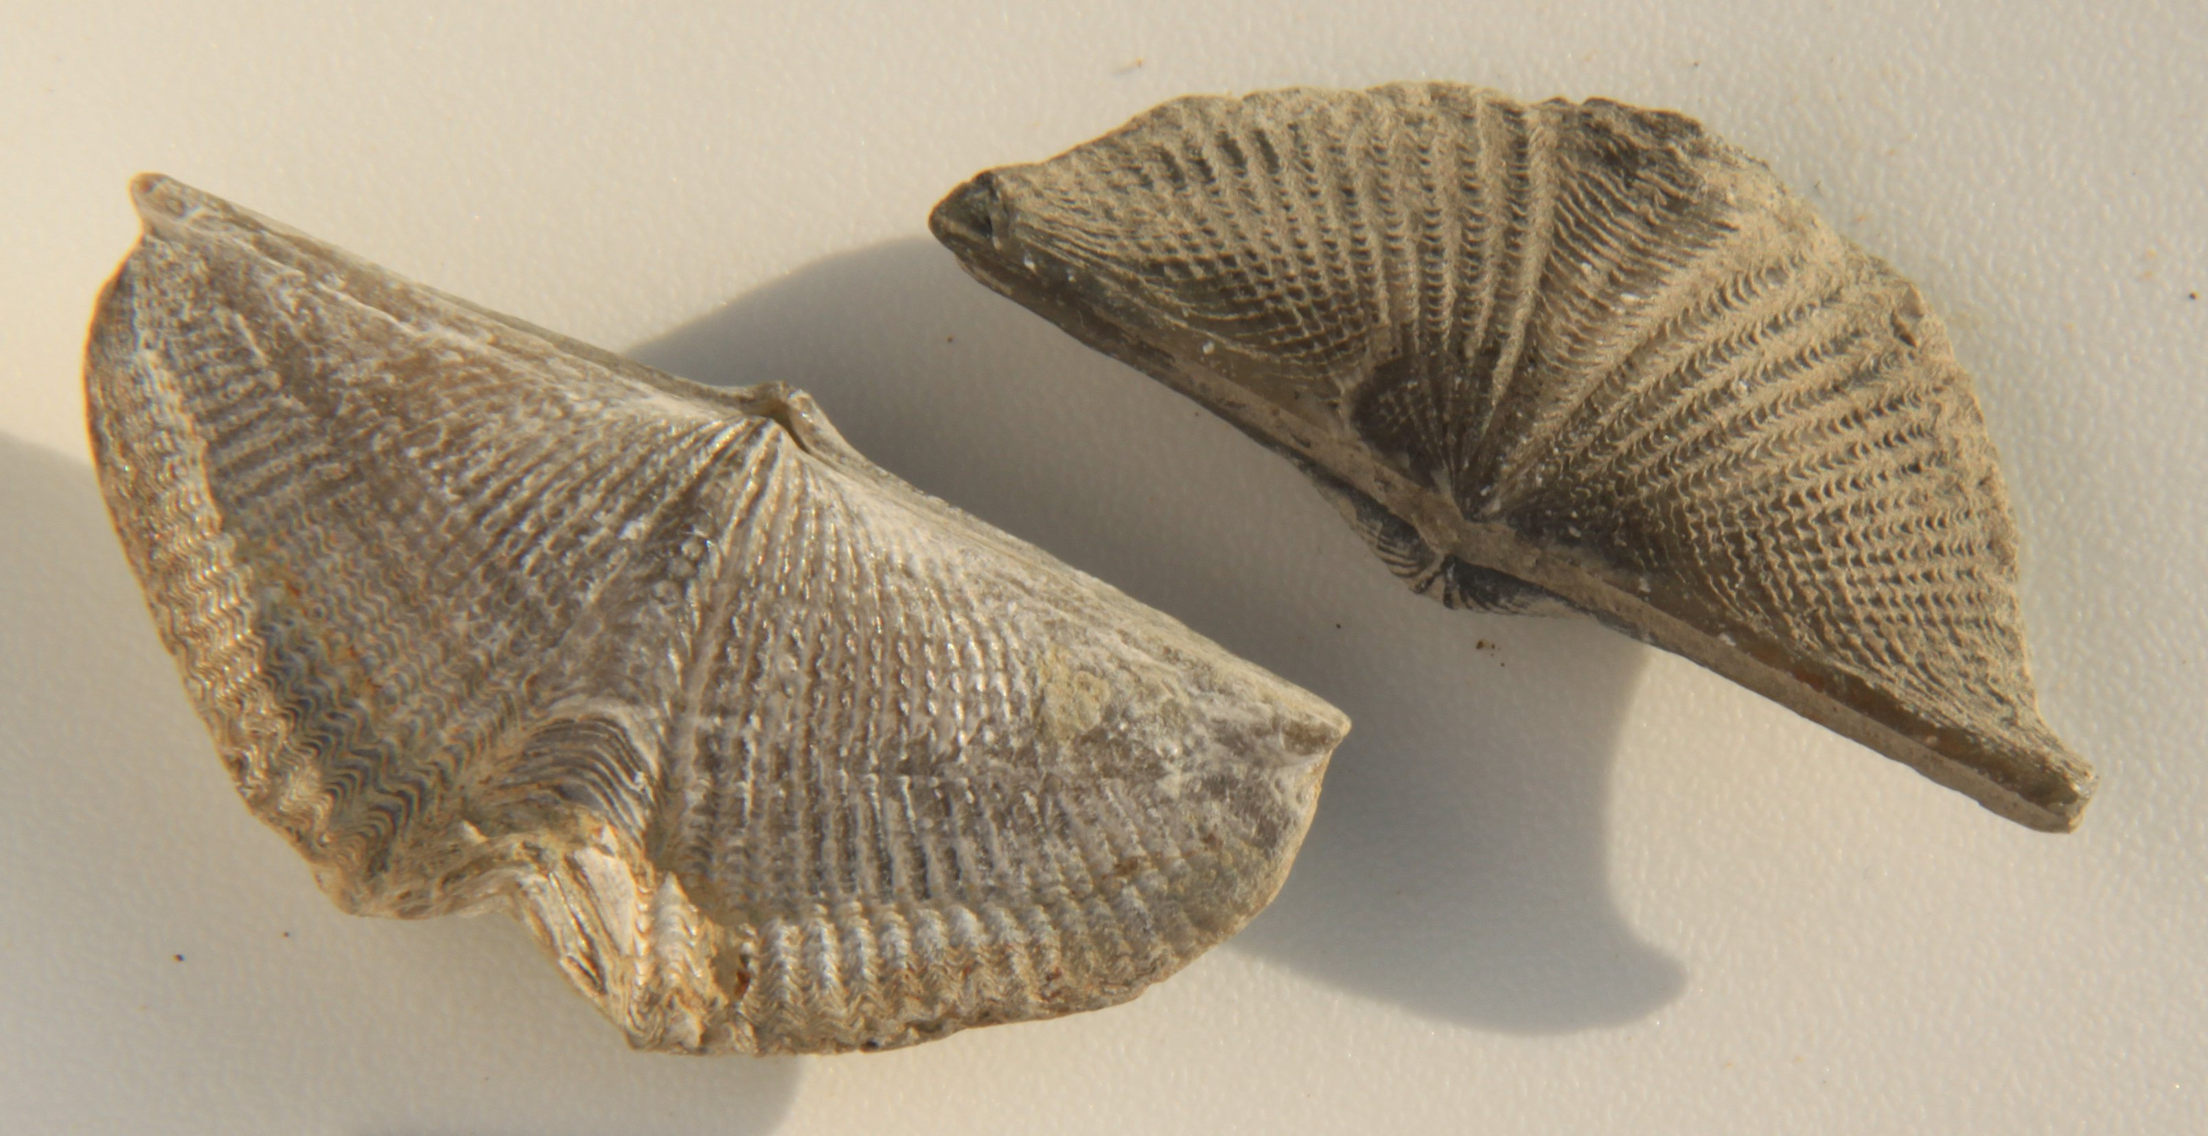

This species was found in rock layers A 3, B4, and C3
ORTHOCERAS (500-190 million years ago)

Orthoceras was an ancient relative to modern-day squid, except it had a long, straight, sword-like shell that covered its body, except for its eyes and tentacles (look up a picture of it online!). They lived in the seas of the ancient world, and were very common for a very long time. Some people confuse them with a species/group that lived much later called Baculites. However, The divisions in their shell are simple and curved, while Baculites has very ornate, folded divisions (See if you can guess which of the fossils was a baculites!). Therefore, Orthoceras are easily distinguished from other similar species based on their shell characteristics.
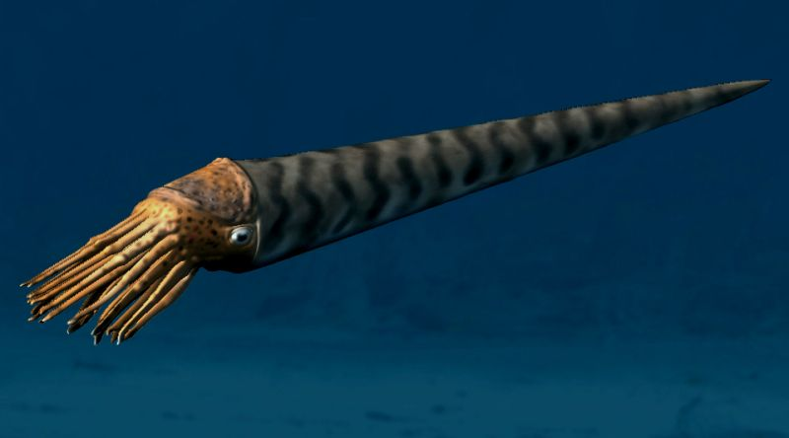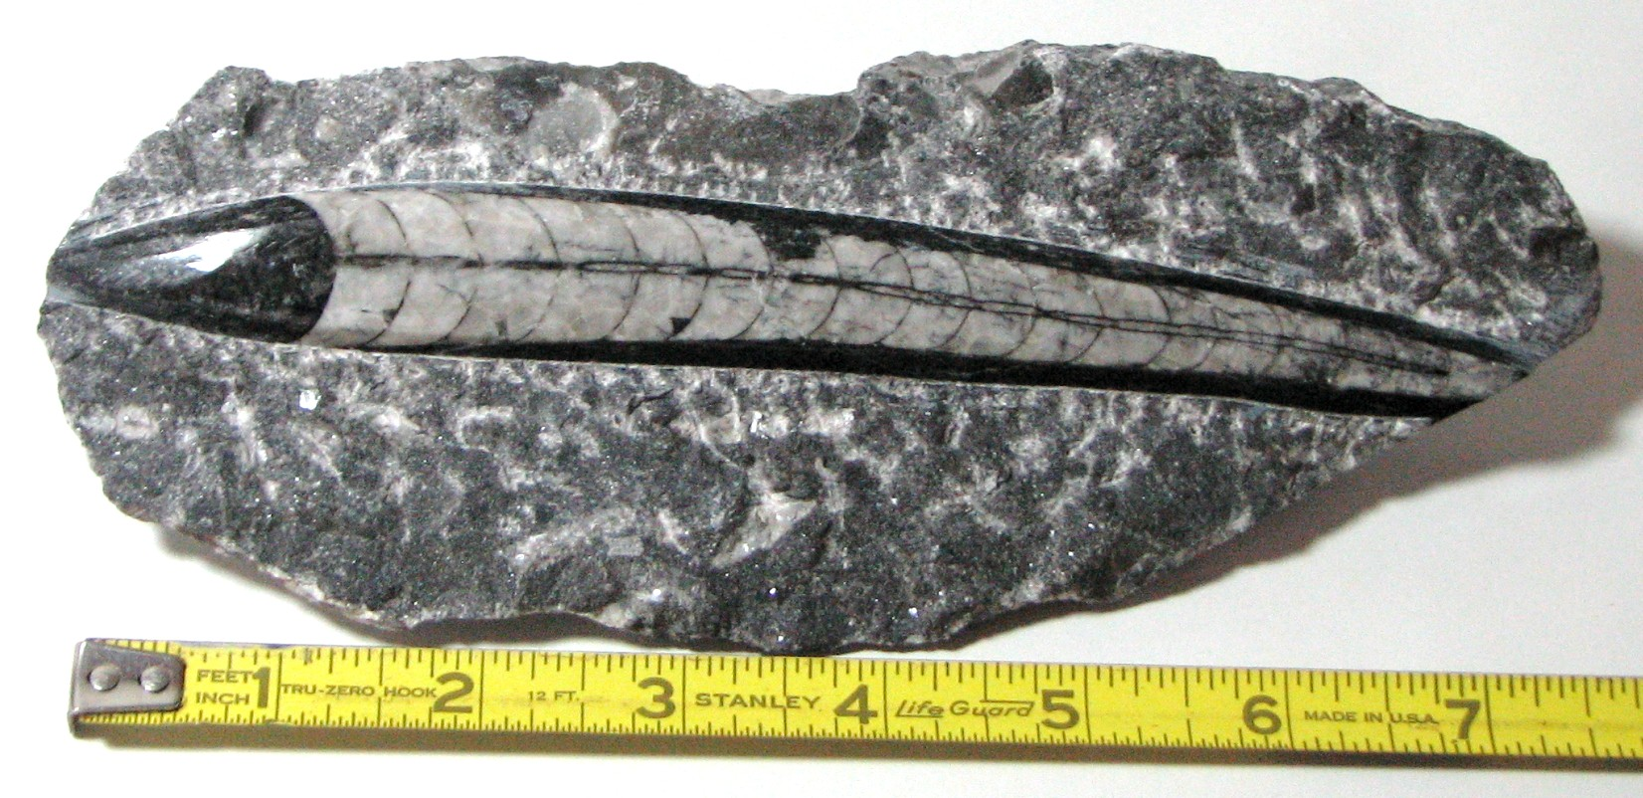

This fossil was found in rock layers A 1,2, 3, 4, 5, and 6
B 1,2, 5, and 6
C 1, 2, 3, 4, and 5

WORTHENIA (SNAIL) (416-200 million years ago)

This ancient snail was a marine snail that lived in the oceans for a very long time in the seas of North America only. It can be found in the area that is now from Texas to Nebraska, which was once a shallow ocean. It has a “turban-like” shape, as do many other species of snails. It can sometimes be difficult to tell a smaller version of this species from other species of snails that lived in the same time periods unless you have a complete fossil, or an undamaged one.
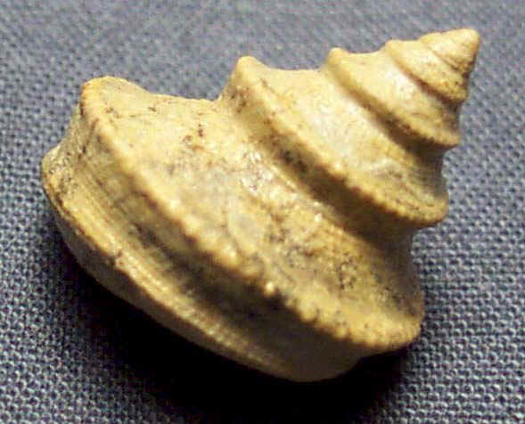

This species was found in A3, A4, A6, B4, C3, and C5

SCLERACTINIAN CORAL (“Mushroom coral”) (242 million years ago—present)

Scleractinian corals are the major reef-builders in the seas and oceans of earth today. They appeared in the middle Triassic, around the time the dinosaurs were on the decline but they have taken off since that time. They are usually colonies of tiny animals called polyps that have a hard outer shell made of calcium carbonate. The shells are usually shaped like a hexagon in colonies, but it can be difficult to distinguish them from each other without details of the skeletons that come in permineralized fossils.

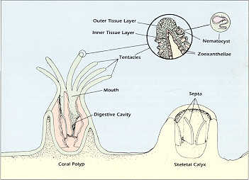

These were found in B7
TRILOBITES (FLEXICALYMENE, PHACOPS, CALYMENE, ELRATHIA)
(521-250 million years ago)

Trilobites are one of the earliest groups of Arthropods, the group that includes crustaceans, insects, arachnids, and millipedes and centipedes. They were some of the top predators in ancient reefs and seas all over the world for millions of years before the age of the Dinosaurs. All trilobites have three lobes to them: a central axial lobe and two pleural lobes (one at each side). However, they are easy to distinguish by species because of other features, like the number of segments, head size, shape of body segments, spines, and many other features. Each individual trilobite species existed for a short period of time and then every so often they would morph into new forms, or go extinct. Each of these trilobites is a different species and has a distinct difference between it and the other trilobites. Trilobites were predators, and are related to modern arthropods like horse shoe crabs, insects, and other segmented creatures
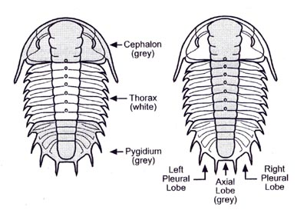
The Phacops (416-359 million years ago) was found in A3, B4, and C3
The Flexicalymene (488-443 million years ago) was found in A2, B2, and C2
The Elrathia (509-497 million years ago) was found in A1, B1, and C1
FERNS (360 million-present, but more common form 360-145 million ago)

Ferns were some of the first land plants that could reproduce, and are therefore very important fossils in the history of life. They require a good amount of moisture to survive, and don’t reproduce with seeds like other plants, but with spores. They were widespread throughout the world for part of earth’s history, and came in tree form, bush form, and everything in between. They can have distinguishing leaflet shapes, but they are often too similar to determine their actual species.
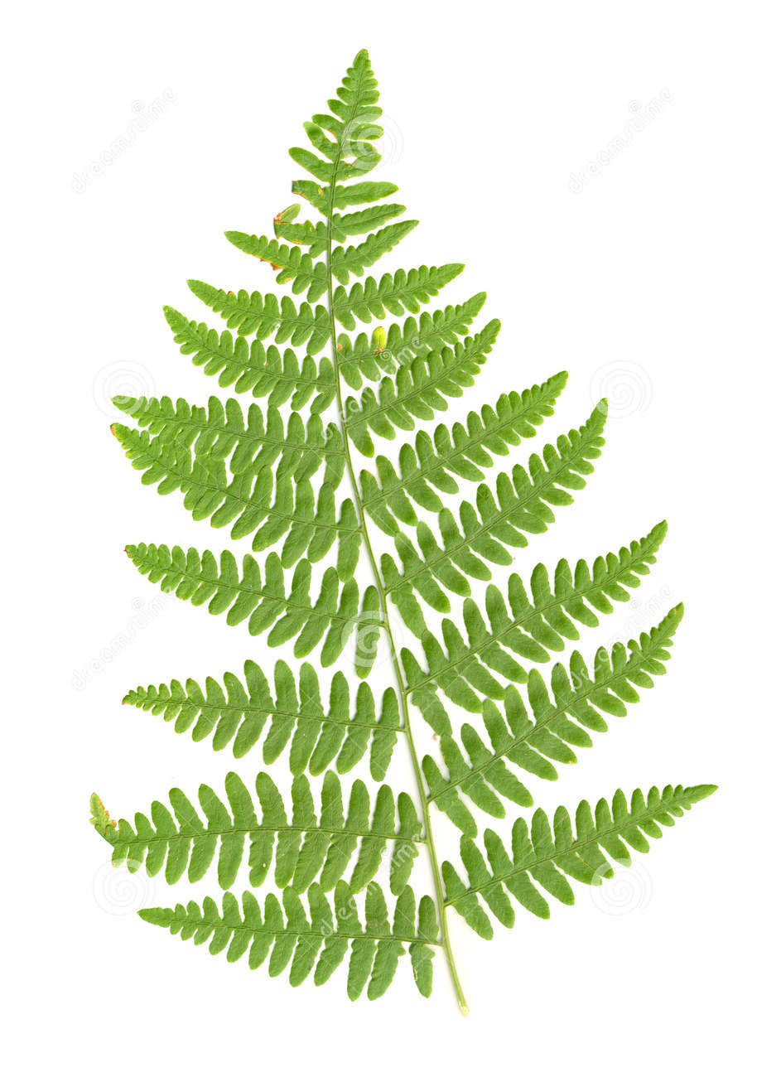
These ferns were found in A6 and A7

ATRYPA BRACHIOPOD (440-318 million years)

Atrypa looks much like modern-day clams and scallops, but it is in no way closely related! This organism is from a group called brachiopods, which dominated the ocean reefs of the world for a very long time before most of them went extinct. They were one of the most widespread groups of organisms in the world. Brachiopods are easily identified from one another because they often have very distinct features. Atrypa was unusual and easily identified because it has a very convex upper shell and a more flat lower shell. It lived in a variety of reefs all over the world.
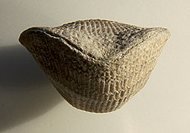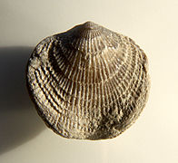

This species was found in rock layers A4, B5, and C4

PENTREMITES (360.7-314.6 million years ago)

Pentremites is related to modern-day starfish and sea urchins. It was part of a group called crinoids, or sea lilies, that made up large reef systems in the past. The Pentremites lived in environments that would often form very detailed, complete fossils, like shallow areas that would be covered in sand from a storm. They grew from the ocean floor off of a hard stalk that looked like stacks of tiny circles. The piece you are looking at was the main body portion, with the digestive system. However, they are called sea lilies because of the fan-like arms that came off the main “head” (or theca). These arms would function to catch food and them bring it to the mouth. Pentremites was easily identified from other Crinoids because of its distinct theca shape and the pattern in its stalk circles.
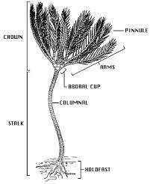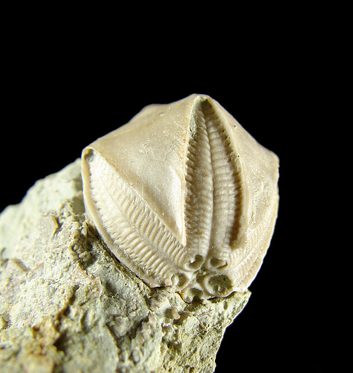

This species was found in rock layers A5, B6, and C5
DINOSAUR (231-65 million years ago)

Dinosaurs were a dominant group of land reptiles that lived all over the world. They had a variety of unique features, but they all had legs that went directly under their bodies (like a dog or lion), unlike other lizards with legs out to the side (think alligators). They also all had the same number of holes in their skull as well. There
were dinosaurs that lived in all environments, and some of them even had feathers. Dinosaurs can be distinguished by close inspection from one another, but oftentimes they have incomplete fossils or only fragments, which makes it tough to tell them apart.

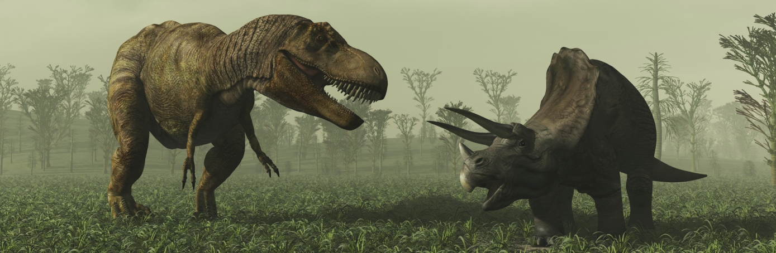

This sample was found in rock layer A6.

BRYOZOANS, ARCHIMEDES and UNKNOWN (480 million to present)

Bryozoans were another group of organisms that grew in reefs. There were many different types before the age of mammals, but there are only a few types left. Bryozoans look very much like coral at first glance, but they are totally different groups of creatures. They do make a small hard skeleton around them, and live in colonies often, but unlike the corals, they have a one-way gut. Corals have a two-way gut…This means food enters in the same place that poop exits…gross! Bryozoans are much more clean! Some bryozoan groups have distinct shapes, like this Archimedes screw example. However, many bryozoans don’t have distinguishing features unless you’re an expert and examine them very closely.

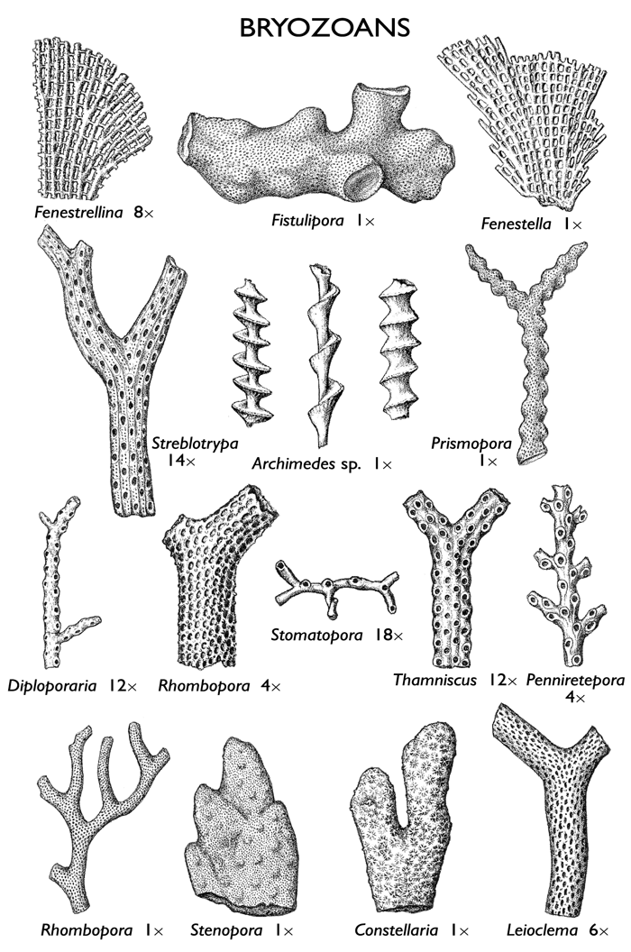
These examples were found in rock layers A2-5 and B2, B4, B6, and B7.
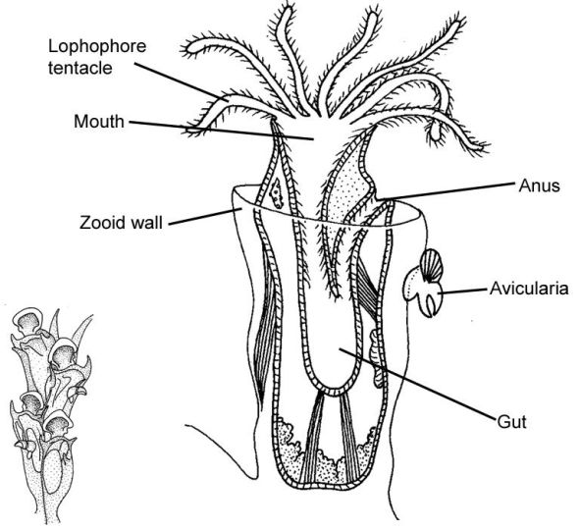
PETRIFIED WOOD (400 million year ago –present )

Petrified wood forms when a tree or other woody plant gets covered suddenly in a flood of sediments, and then they are filled with water and minerals which crystalize. These fossils are often formed after floods, landslides, volcanic eruptions, and other events that cover the wood quickly.
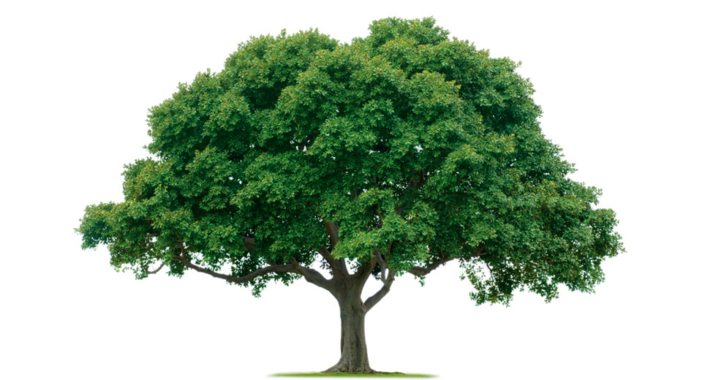
This example was found in rock layers A6, A7, and B3.

