Gerhardt Fahrt…the Curious old Stinker
From a young age, Gerhardt Fahrt didn’t like school. Though he was bright, his peers would constantly poke fun at him for his last name. Fahrt. They would make toots and blurts when he was called on in class, and they would pretend they smelled clouds of gas as he walked by at recess. Poor Gerhardt Fahrt would just count the minutes until he could go home and watch David Hasselhoff videos and eat sauerkraut.
But because he was acquainted with watching clocks all day, Fahrt was also infatuated with clocks! From those grade-school years, all he cared about was the accuracy of cuckoo clocks and chimes of grandfather clocks. As a result, he never paid attention in school, unless it had to do with time, or numbers, or clock gears. He missed out on a lot of learning, but he grew to become the greatest clockmaker in Germany! He grew a wonderful business called Fahrt’s Time that sold watches and clocks all over the world, despite the name.
One day, world-famous scientist Neil DeGrasse-Tyson stepped into his shop and asked for a solar-powered watch that also had a lunar cycle timepiece added to it. Fahrt felt some pressure to get the watch out to the famous man, but he was up to the challenge. In the meantime though, Mr. DeGrasse-Tyson, being a personable fellow, began to ask Fahrt about his work, and tell him about his own. He revealed some facts about the universe that Fahrt had never let stew in his own mind.
Even though he was a success now, Mr. Farht decided there must be more to life than cuckoo clocks. He decided to get out and explore the world he lived in. This is the story of one of his adventures.

Gerhardt Fahrt decided to begin learning about his world by traveling to beautiful Switzerland. It was home to famous watchmakers, and it was practically next door to Germany!

After a five hour train ride, Fahrt found himself approaching the base of a beautiful mountain, deep inside its U-shaped valley.
The view was spectacular. Gerhardt thought, “All my life I’ve had my head inside of clocks. I’ve missed so much.” Trying not to cry in front of the strangers nearby, Gerhardt pretended there was a fleck of dust in his eye, and stepped off the train.

Mr. Fahrt stared up at the mountain and just observed the majesty around him. He smelled the scent of odoriferous cheeses and decadent chocolates wafting through the air. He heard the sounds of yodeling in the background. He felt the chill of mountain air blowing on his bald head. It gave him a warm feeling of….neutrality. Then he noticed something strange.
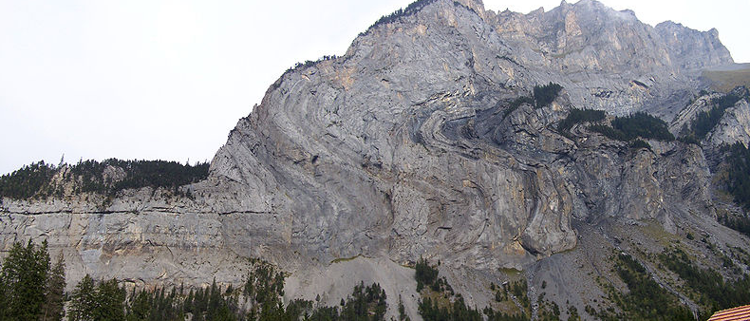
Mr. Fahrt noticed that there was a strange pattern in the rocks on the valley wall. It was nothing like anything he’d seen before. It looked like stacked crepes that had been folded. He decided to go investigate, thinking, “This won’t take long! Then I’ll go eat some Schnitzel.”

Three hours later, Fahrt was pooped. He had hiked up the mountain side and saw that he was far above the little town. However, his new position gave him some leverage to see something new. From close up, he could see the patterns he had seen below were actually different layers of rock that were bent in all sorts of crazy directions.
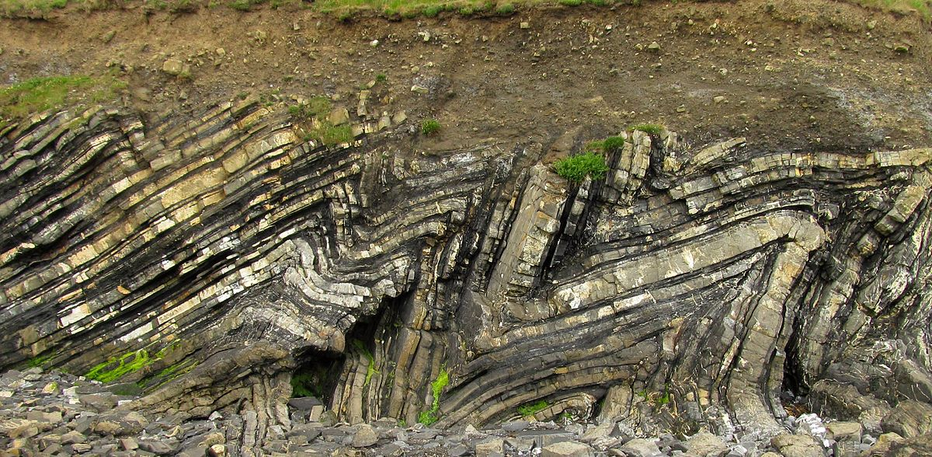

“That’s strange,” Fahrt thought. “How could rocks get folded like that?” Mr. Fahrt began walking farther along the trail. A strong wind blew up, almost knocking him sideways. “Whoah, I better be careful,” Mr. Fahrt said aloud. “That wind crept up on me. It was silent….but could be deadly.”

Fahrt managed to stay on the trail when he got tired again and sat down. He pulled out a small bottle of water to drink, but dropped it. When he reached to grab the water bottle, he noticed something strange on the rocky trail.
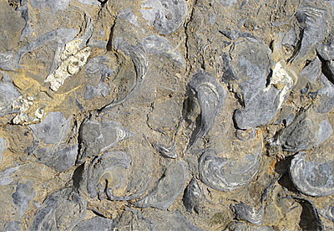
The rocky surface he looked down at seemed to have some strange shapes inside of them. They reminded him of oyster shells that he had once put on a clock for the Gorton’s Fisherman. But how would Oysters get all the way up here? Silly!

Mr. Fahrt was getting winded, so he made his way back down the mountain. He decided to spend the night, and after a nice dinner of schnitzel (not schnauzer), he walked through the town. There was a beautiful clock museum in an ad, but when he arrived, he found it was out of business. Nobody cared about clocks, and so it closed. #sadness.

Then Mr. Fahrt found a museum of natural history and decided to go inside. He was immediately greeted by a large fossil which read in German, “The inspiration for the Alien.” He read through the plaque and found the fossil had inspired the Alien in the classic 1979 movie, but that it was also from Switzerland.

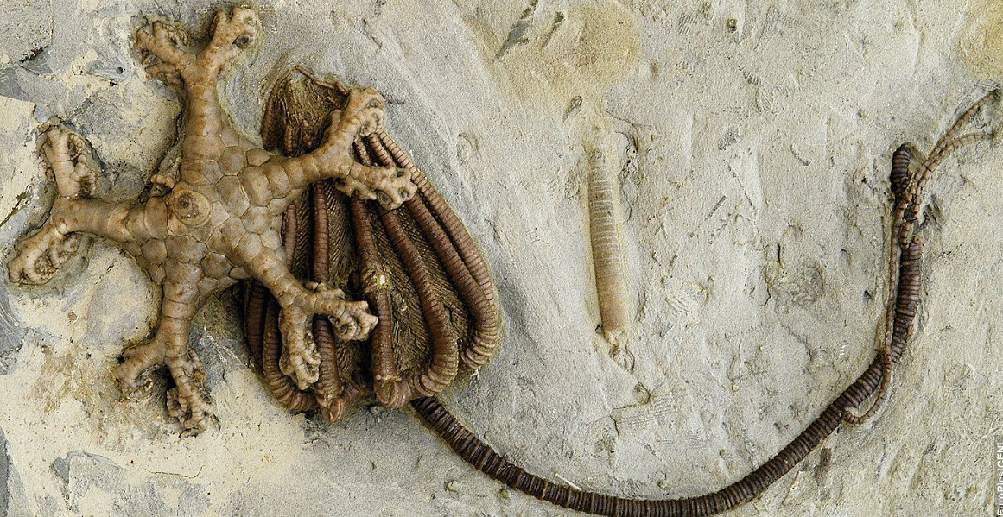

Gerhardt read that the fossil was actually two fossils: A crinoid and a blastoid. He read that it was related to starfish, and lived in the shallow oceans of the Paleozoic era….Whatever that was. “Hey! That’s before the dinosaurs,” he said to himself. After geeking out for about 5 minutes because of the time scale involved with the fossil, Gerhardt moved on.

The museum closed at 9, so Mr. Fahrt made his way back to the hotel he was staying at. That night he dreamt of a ticking clock.

The next day, Mr. Fahrt prepared for a train ride to another part of Switzerland. On the train, he looked out the window and saw a strange pattern in the rocks again. This time, it looked like the mountains had been cracked in several places.
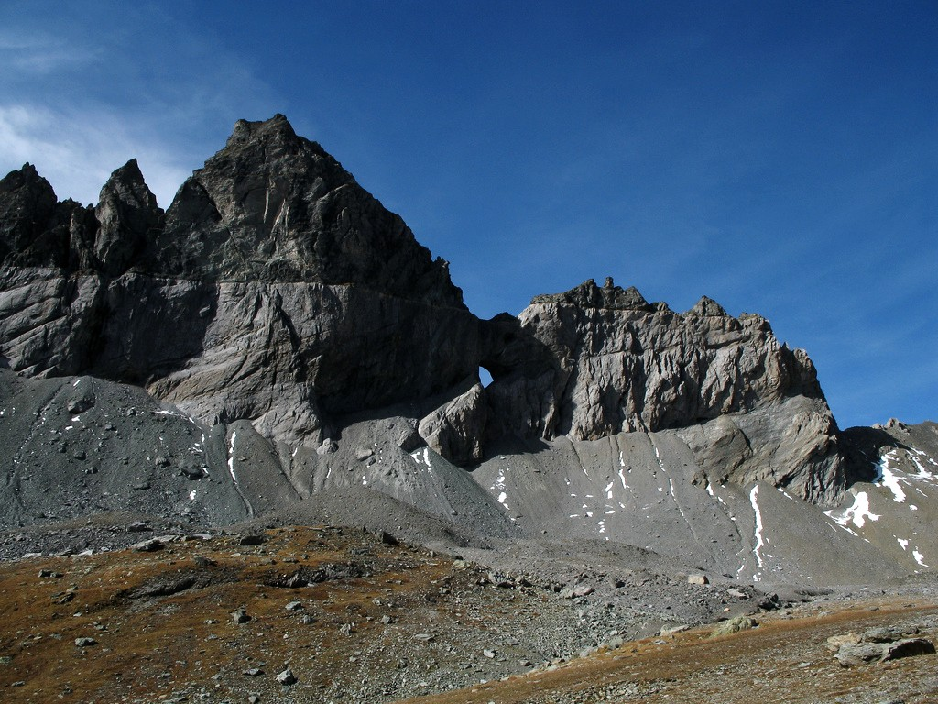

“How could an entire mountain crack?” Fahrt wondered. If only Mr. Fahrt had paid attention to Herr Schöpferkraft, his 8th grade science teacher. He realized that there was so much of the world he did not understand. Fahrt was now determined to investigate the strange things he saw on his new journey. He also wanted to find out why everyone laughed when he introduced himself, but that could be saved for another time.

In your reading, please annotate the following things:
- Character (Who)
- Plot (Where, When)
- Setting
- Vocabulary
- Three questions
- Three inferences
- Tone
- Choose one other thing to annotate

