CELL NOTES
Name___________________________
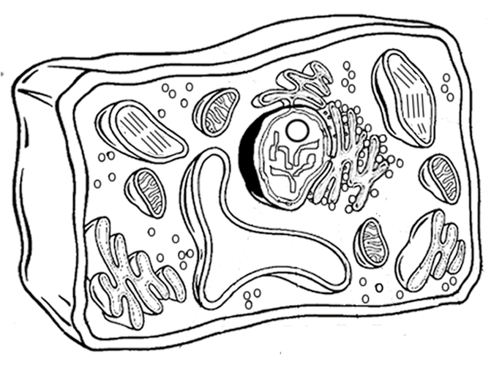
Match the following vocab words to their definitions by writing the corresponding letter on the line.
- The “brain” of the cell, contains the DNA that directs all the activities in the cell
- The liquid that is the “guts” of the cell, made of sugars and proteins where metabolism occurs.
- Rings of 9 fused microtubules, used during cell division to move objects
- Organelle that is used to turn sunlight, water and CO2 into glucose during photosynthesis
- The “skin” of the cell that allows and prevents some substances to pass in and out of the cell
- Stacks of membranes that act as the “UPS” of the cell, packing and shipping things around.
- Small bubbles filled with chemicals that break down materials for cellular digestion.
- Small bubbles filled with chemicals that break down foreign substances.
- Large empty pockets inside of cells that can contain food, water, or waste materials
- Small organelles that are responsible for making proteins
- The “Highway” of the cell, it is responsible for transporting materials around the cell.
- The “Powerhouse” of the cell, it makes energy for the cell using ATP and oxygen
- A series of connected pathways, dotted with ribosomes, that helps modify proteins
- A rigid, protective layer made of cellulose that helps plant cells maintain their shape
- _____ Nucleus

- _____ Cell membrane

- _____Ribosome

- _____Mitochondria

- _____Cytoplasm

- _____Golgi Bodies

- _____ Rough Endoplasmic Reticulum

8._____ Smooth Endoplasmic Reticulum

9._____ Vacuole

10._____ Cell Wall

11._____ Chloroplast

12._____ Centriole

13._____ Lysosome

14. _____Peroxisome

Use the following words to correctly label the diagram of the plant cell below.

Chloroplast

Nucleus

Vacuole

Mitochondria

Cell Wall

Golgi Body

Rough ER

CELL ANALOGY ACTIVITY

Purpose: Create an analogy for the cell, assign “characters” in your analogy for the cell parts, and then write a quote that they might say that indicates their role in the cell.

1. What is your analogy? Choose a setting, organization, group of people, team, etc. that works together toward a common goal. This will function as your analogy for the cell.

My Analogy is ____________________________________________

2. Every functional group has people with different roles. Look at the cell parts on the front and determine who in your organization could function as each of the following things:

Nucleus= ____________________ because____________________________________
_____________________________________________________________
Mitochondria= ____________________ because________________________________
_____________________________________________________________
Cell Membrane= ____________________ because______________________________
_____________________________________________________________
Chloroplast= ____________________ because________________________________
_____________________________________________________________
Ribosomes= ____________________ because__________________________________
_____________________________________________________________
Vacuole= ____________________ because____________________________________
_____________________________________________________________
Endoplasmic reticulum=___________ because__________________________________
_____________________________________________________________
Lysosome= ___________________ because____________________________________
_____________________________________________________________

3. Finally, color the picture of the cell. Then, give each of the 8 organelles above a quote that the person might say which indicates their job in the cell.

