**Limestone**

This rock is made from the minerals that used to form the shells of **marine** organisms like coral, bivalves (clams, oysters, ect) and some microscopic organisms called foraminifera. Most of these organisms don’t live in very deep water. Coral, especially, needs shallow water because it has an algae that lives inside of it that needs light to help survive. The mineral grains are very small, and can be carried away easily in moving water. So, moderately deep water that isn’t prone to currents or wave action would be a place where limestone forms.

1. Which of these places might limestone form? (Select all that apply)

a) Fast-moving river

b) a coral reef

c) Shallow ocean water

d) deep ocean water

**Sandstone**

Sandstone is first formed when ancient sand settles out in water that is relatively low-energy, or in areas where there are large amounts of sand that build up on top of one another. Over time, the sand is compacted, and some amount of moisture causes the sand to cement together.

2. What are some places where sandstone would form? Name 3 specific watery environments and 1 land environment where sandstone could form. (HINT: Where would you find sand today?)

**Conglomerate and Breccia**

Conglomerates and Breccias are stones that are made of sediments larger than sand grains. Conglomerates are typically rounded sediments, and breccias are made of sediments that are very angular. The conglomerates usually have rounded pebbles because they are in areas of water, which acts to round them. Breccias are usually in areas that are volcanic. Both form in environments with large amounts of energy (which carries away the smaller sediments) and places where the energy level changes (allowing varied sizes of rocks).

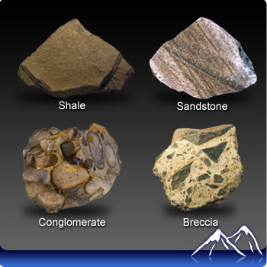

3. Explain which type of rock (Conglomerate or Breccia) may have formed in each of these environments, and how it formed:

a) in a glacial environment

b) In a fast-moving river

c) Volcanic area

**Coal**

Coal is made from the compressed remains of ancient organic matter, mainly plants. The dead plant matter is deposited in very large amounts on the ground, but then it would also have to be covered so that oxygen does not allow the plant matter to decompose. Areas where plants can grow, but their leaves can also get covered quickly when they fall down, area good areas for future coal deposits.

Which of these environments would be a better place for coal to form? Explain.

4. Swamps or forests? (may need to look up what a swamp is)

5. Wetlands or grasslands?

**Evaporite Deposits**

The most familiar evaporite deposit would be salt deposits. Evaporite deposits would form where salt water evaporates in large quantities, leaving the salt behind to form into large rock deposits.

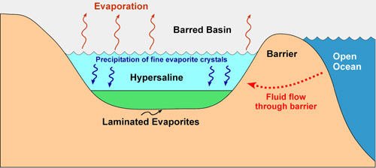

7. Explain how plate tectonics might contribute to large salt deposits in the future for the Mediterranean area.

8. If you found salt deposits in an area, what would you know about that area in the past?

**Glacial Till**

Glacial Till is a special kind of soil that forms in areas where there has been glacial activity. The glacier carves out, carries along, and pushes along rock sediments of all sizes. When the glacier melts or recedes, the glacial sediments are left over. It is a mixture of soil, large rocks, small rocks, pebbles, sand, and other debris. It typically has both rounded and angular rock grains in it, of many different sizes.

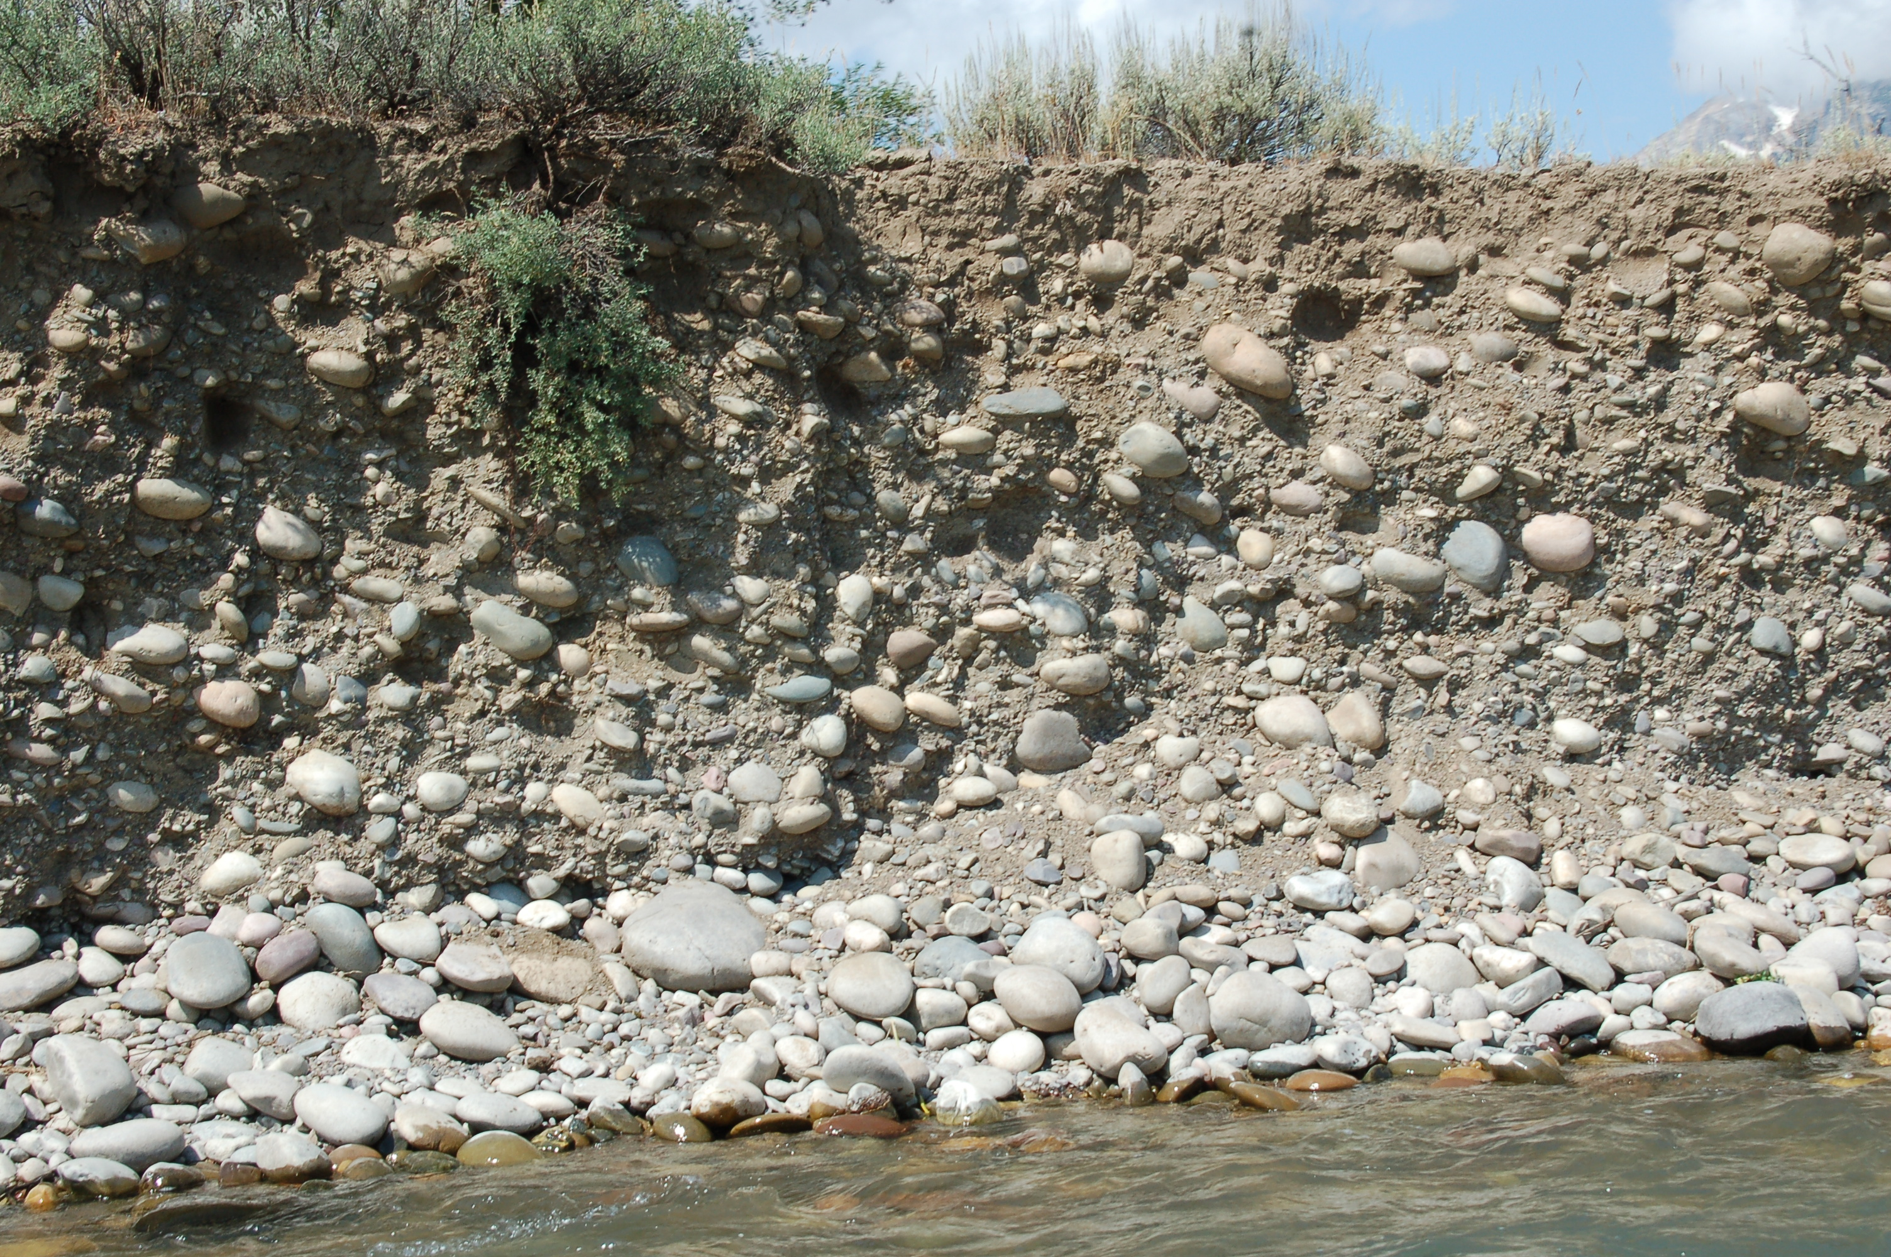

9. If you found a rock that looked like glacial till, what would you know about the area when it formed?

Ripple Marks

Ripple marks form where light, regular wave action reshapes sediments into the shapes you see in front of you. The waves must be regularly occurring, and the water can’t be too deep (won’t move the sediments) or too shallow (it will knock the sediments over flat).

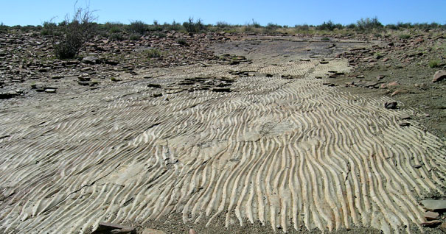

10. What types of environments would create ripple marks?

Mud cracks

Mud cracks form when mud is deposited in large amounts and then dries out. If the cracked mud gets covered again, it will preserve the mud cracks.

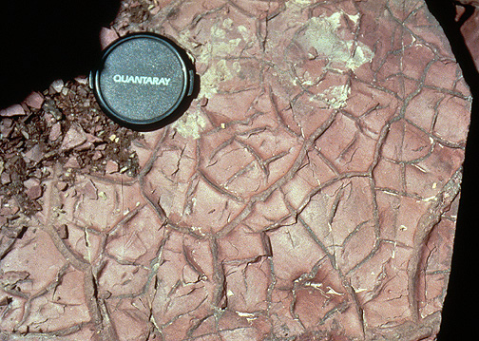

11. What areas would be common places to find mud cracks? In what climate would you expect to find mud cracks? Why?

Fossils

Ancient Greeks and the people of medieval Europe thought that the fossils in the earth had formed inside the rock, or that they were animals of some sort that died inside of rock. But when the Greeks found fish on mountains, they thought that perhaps the fish swam through cracks in the rocks and then died on the mountains. Today, we know that fossils are the leftover remains of ancient organisms, or evidence of their activity, that have turned into rock. The fossils that are found in rocks tell something about what the environment was like when the organism died.

12. Make a Chart in your answers and tell what kind of organism the Fossil A and Fossil B is, and what this fossil would tell us about the depositional environment in column 2.

**Grain Size**

The grains that make up a sedimentary rock are typically smaller in low energy environments, but larger in high-energy environments. Rocks that have large pebbles or large sand grains are in fast-moving water often. Rocks with tiny sediments that make them up (sometimes too small to see) are often formed in calm water.

13. Which of these rocks would have probably been formed in the bottom of a lake? How about the edge of a river?

**Angular vs. Rounded grains**

The grains of a rock are more rounded when they’ve undergone more abrasion, typically in a watery environment. If the sediments in a rock are more rounded, it was likely in water, but if the sediments are more angular (pointy) then the rock may have been in a dry location.

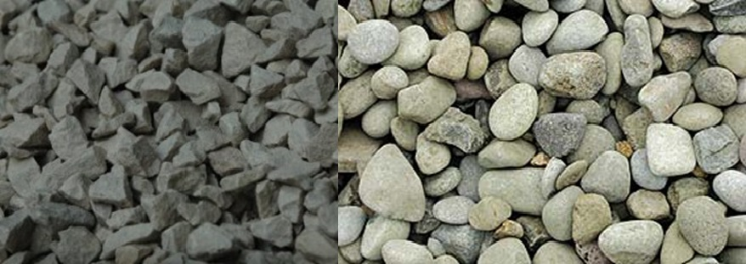

14. Was this rock more likely formed in water or in a dry environment?

**Faulting and Folding**

Faults and folds are caused by large compressional or tensional forces in an area, leading to the sedimentary rocks being cracked (faulted) or folded.

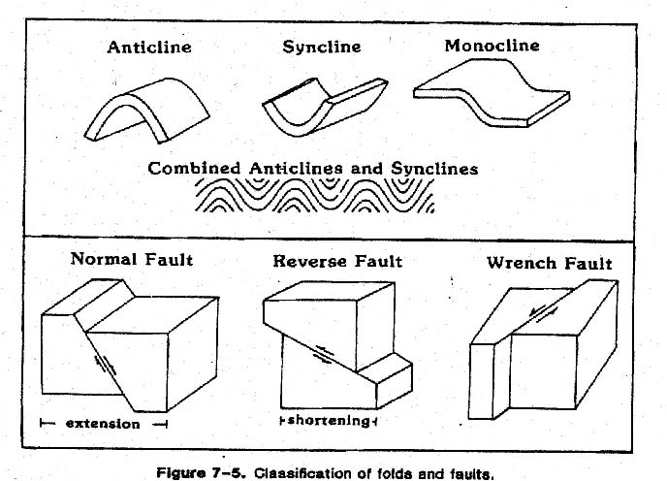

15. Where would we find lots of folding and faulting in rocks? What would these folds and faults tell us about what’s going on in that area in the past?

**Igneous rock**

With igneous rocks, grain size is related to crystals, not individual sediments. The crystal grains are often differentiated from each other by having different colors. You can sometimes see the individual crystals clearly with your eyes. The mineral grains are smaller if a rock cooled off very quickly, but they are larger if the rock cooled off very slowly. They can sometimes be as big as a human!

16. Which of these rocks probably formed by cooling inside the earth?

17. Which of them indicate that a volcano may have been there? Explain.

Fossil size and 02

Sometimes in the fossil record, we find that organisms change in size DRAMATICALLY! For example, the common millipedes we see today are usually only about 2-3 cm long. However, there are fossils that show these organisms once grew to over 100 cm! That’s a big millipede! Scientists have found that these increases in size are largely due to more oxygen being available in the atmosphere.

18. The fossils in front of you, which look like rice grains, are called foraminifera. They are marine organisms that float about in the ocean, making up a basis for much of the food chain. These fossil examples are as large as rice grains. However, the same living foraminifera today are microscopic. What does their size tell you about when these organisms were alive?

Rusting

Rocks that have red in them are usually red because they have “rusted”. Rust happens when iron and oxygen mix together. Rusting doesn’t require water, but water acts as a “catalyst”. A “catalyst” is something that speeds up a chemical reaction, but it doesn’t actually need to be there for the reaction to occur. So, rusting usually happens in areas where there is shallow water, because there is access to oxygen in the atmosphere and there is water to speed up rusting.

19. What can these rocks tell us about the depositional environment?

20. This rock has a reddish/pink band, a tan band, and another reddish/pink band. What does the presence of rust in this rock tell us about the atmosphere when the rusted rock formed? Why do you think the rock has some areas of no rust?

**Depositional Environments Lab**

Name________________________

**Limestone**

1. Which of these places might limestone form? (Select all that apply)

a) Fast-moving river c) Shallow ocean water

b) a coral reef d) deep ocean water

**Sandstone**

2. What are some places where sandstone would form? Name 3 specific watery environments and 1 land environment where sandstone could form. (HINT: Where would you find sand today?)

Watery a. _______________________________

b. _______________________________

c. _______________________________

Land d. _______________________________

**Conglomerate and Breccia**

3. Explain which type of rock (Conglomerate or Breccia) may have formed in each of these environments, and how it formed:

a) in a glacial environment_____________________________________

__________________________________________________________

__________________________________________________________

b) In a fast-moving river_______________________________________

__________________________________________________________

__________________________________________________________

c) Volcanic area________**_____________________________________**

**__________________________________________________________**

**__________________________________________________________**

**Coal**

Which of these environments would be a better place for coal to form? Explain.

4. Swamps or forests? (may need to look up what a swamp is)

________________________________________________________________

________________________________________________________________

5. Wetlands or grasslands?

________________________________________________________________

________________________________________________________________

**Evaporite Deposits**

7. Explain how plate tectonics might contribute to large salt deposits in the future for the Mediterranean area.

________________________________________________________________

________________________________________________________________

________________________________________________________________

________________________________________________________________

8. If you found salt deposits in an area, what would you know about what that area was like in the past?

________________________________________________________________

________________________________________________________________

________________________________________________________________

________________________________________________________________

**Glacial Till**

9. If you found a rock that looked like glacial till, what would you know about the area when it formed?

________________________________________________________________

________________________________________________________________

________________________________________________________________

**Ripple Marks**

10. What types of environments would create ripple marks?

________________________________________________________________

________________________________________________________________

________________________________________________________________

**Mud cracks**

11. What areas would be common places to find mud cracks? In what climate would you expect to find mud cracks? Why?

________________________________________________________________

________________________________________________________________

________________________________________________________________

________________________________________________________________

**Fossils**

12. Make a Chart in your answers and tell what the fossil is in column 1, and what this fossil would tell us about the depositional environment in column 2.

|  |  |
| --- | --- |
| Fossil Type | Environment (marine or terrestrial) |
|  |  |
|  |  |
|  |  |

**Grain Size**

13. Which of these rocks would have probably been formed in the bottom of a lake? How about the edge of a river?

________________________________________________________________

________________________________________________________________

**Angular vs. Rounded grains**

14. Was this rock more likely formed in water or in a dry environment?

________________________________________________________________

________________________________________________________________

**Faulting and Folding**

15. Where would we find lots of folding and faulting in rocks? What would these folds and faults tell us about what’s going on in that area in the past?

________________________________________________________________

________________________________________________________________

________________________________________________________________

________________________________________________________________

**Igneous rock**

16. Which of these rocks probably formed by cooling inside the earth?

________________________________________________________________

________________________________________________________________

17. Which of them indicate that a volcano may have been there? Explain.

________________________________________________________________

________________________________________________________________

**Fossil size and 02**

18. The fossils in front of you, which look like rice grains, are called foraminifera. They are marine organisms that float about in the ocean, making up a basis for much of the food chain. These fossil examples are as large as rice grains. However, the same living foraminifera today are microscopic. What does their size tell you about when these organisms were alive?

________________________________________________________________

________________________________________________________________

________________________________________________________________

**Rusting**

19. What can these rocks tell us about the depositional environment?

________________________________________________________________

________________________________________________________________

________________________________________________________________

20. This rock has a reddish/pink band, a tan band, and another reddish/pink band. What does the presence of rust in this rock tell us about the atmosphere when the rusted rock formed? Why do you think the rock has some areas of no rust?

________________________________________________________________

________________________________________________________________

________________________________________________________________

________________________________________________________________

Types of Depositional Environments- Do a short internet search and define these.

Continental_________________________

Alluvial an aquatic -___________________________________________________

Aeolian-____________________________________________________________

Fluvial-____________________________________________________________

Lacustrine-__________________________________________________________

Transitional-__________________________

Deltaic-____________________________________________________________

Tidal-______________________________________________________________

Lagoonal-___________________________________________________________

Beach-_____________________________________________________________

Lake-______________________________________________________________

Marine-______________________________

Shallow water marine environment_______________________________________

Deep water marine environment_________________________________________

Reef-______________________________________________________________

Others

Evaporite-___________________________________________________________

Glacial-_____________________________________________________________

Volcanic-___________________________________________________________