Relative Dating Practice

Name___________________________________________

Order the rock layers or events in each diagram from oldest on bottom to most recent on top.

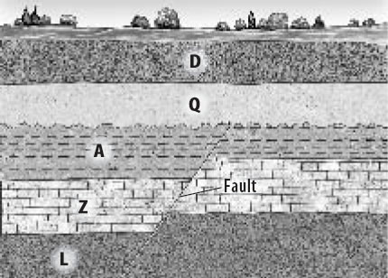

**F**

**M**

______________Youngest

______________

_____________

______________

______________

______________

______________ Oldest

1.

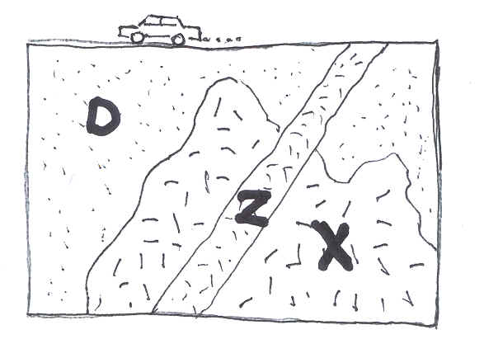

______________Youngest

______________

______________ Oldest

2.

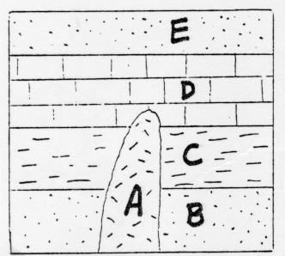

______________Youngest

______________

______________

______________

______________ Oldest

3.

______________Youngest

______________

______________

______________

______________

______________ Oldest

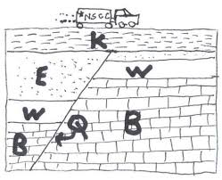

Z

4.

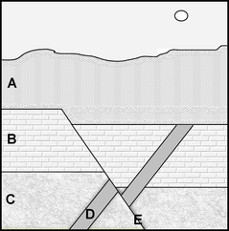

______________Youngest

______________

______________

______________

______________ Oldest

5.

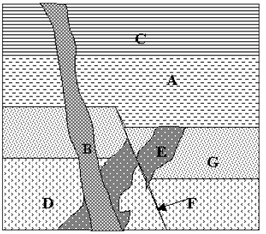

______________Youngest

______________

______________

______________

______________

______________

______________ Oldest

6.

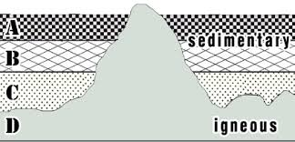

______________Youngest

______________

______________

______________ Oldest

7.

8.

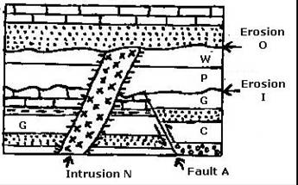

______________Youngest

______________

_____________

______________

______________

______________

______________

______________ Oldest