Geologic Features and What they tell us Worksheet

Name________________________________________
Reverse Fault Folding Unconformity Limestone Shale Evaporites
Normal Fault Tilting Igneous Intrusion Conglomerate Sandstone

1._________ A reverse fault may be caused by
a) a convergent boundary b) Divergence c) volcanism d) flooding

2. _________ A normal fault can be caused by
a) a convergent boundary b) Divergence c) volcanism d) flooding

3. _________ Folding might be caused near a
a) a convergent boundary b) Divergent boundary c) volcano

4. _________Tilting could be caused by
a) volcanic uplift b) glacial erosion c) sea level change

5. _________ Unconformities could be caused by
a) glacial erosion b) sea level change c) volcanism d) A and B

6. _________ Igneous intrusions will tell that an area
a) had volcanic activity in the past c) is very old
b) was once covered in water d) was once near a transform boundary

7. __________ In which area would limestone form?
a) A coral reef area b) a desert c) a mountain side d) a lake

8. __________ Using the following options, where would shale be most likely to form
a) the deep ocean b) a desert c) a mountain side d) a deep lake

9. __________ Glaciers and ocean edges would likely form what type of rocks?
a) limestone b) shale c) conglomerate d) evaporates (salt, gypsum)

10. _________ Sandstone won’t form in
a) beach areas b) deep ocean areas c) river banks d) deserts

11. _________ If the Mediterranean sea closed off and evaporated after thousands of years, it would form what type of rocks?
a) Limestone b) shale c) evaporates d) conglomerates

12. _________ A rock outcrop (section of rock layers) has an unconformity with limestone on top of it. This area probably
a) was eroded by a glacier c) melted away by volcanism
b) had sea levels rise and erode the area d) had sea levels drop and deposit the rock

13. _________If you have limestone on top of shale, on top of sandstone, this means the sea levels
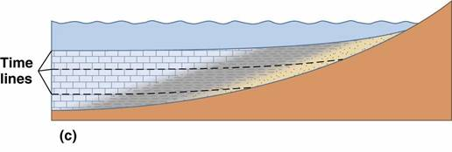
a) rose (transgressive sequence)
b) dropped (regressive sequence)
c) stayed the same
The diagram below shows an area of the Grand Canyon. Please match the events below to their correct letter in the diagram.
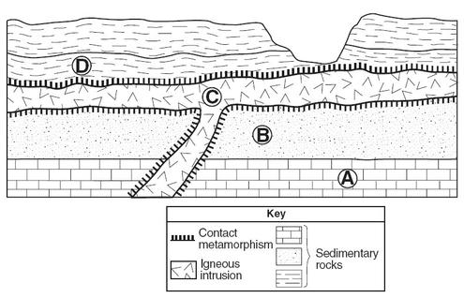

_____________ Sea levels rose and deposited silt. The sediments compacted, forming stone.

_____________ Sea levels were high and supported many organisms with shells, and forming reefs

_____________ Volcanic activity cut across rock layers and deposited a layer of lava over the surface that
cooled and formed an igneous rock layer.

____________ Sea levels dropped and deposited sand and larger sediments, which compacted and
cemented to form rock.

Now determine the correct order of these events based on the diagram above, using number 1-4. (HINT: use the diagram to determine the correct order of the letters).

_____________ Sea levels rose and deposited silt. The sediments compacted, forming stone.

_____________ Sea levels were high and supported many organisms with shells, and forming reefs

_____________ Volcanic activity cut across rock layers and deposited a layer of lava over the surface that
cooled and formed an igneous rock layer.

____________ Sea levels dropped and deposited sand and larger sediments, which compacted and
cemented to form rock.

